**IOT Assignment-13**

(Dheeraj Tiwari)

1. Perform an experiment on Automatic Lighting System Using Arduino, LDR and relay module and status show on Serial Monitor.

Ans:

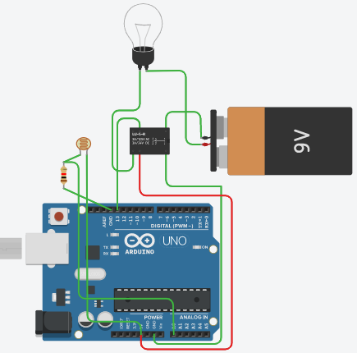

int sensorPin = A0; // select the input pin for LDR

int sensorValue = 0; // variable to store the value coming from the sensor

void setup() {

pinMode(A0, INPUT);

pinMode(13,OUTPUT);

Serial.begin(9600); //sets serial port for communication

}

void loop() {

sensorValue = analogRead(sensorPin); // read the value from the sensor

Serial.println(sensorValue); //prints the values coming from the sensor on the

if(sensorValue<=500){

digitalWrite(13,HIGH);

}else if (sensorValue>500){

digitalWrite(13,LOW);

}

delay(100);}

1. Perform an experiment to turn on 3 LEDs and operate buzzer when LDR Sensor Values varies 599-620 Turns on LED and when values go above 620 that time buzzer active.

Ans:

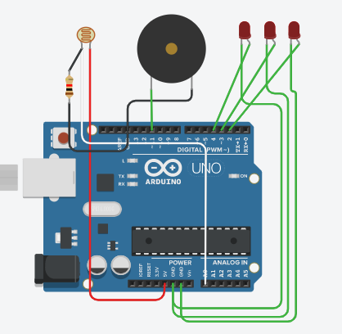

int senVal=0;

void setup()

{ pinMode(A0,INPUT);

pinMode(11, OUTPUT);

pinMode(4, OUTPUT);

pinMode(3, OUTPUT);

pinMode(2, OUTPUT);

Serial.begin(9600);

}

void loop()

{

senVal=analogRead(A0);

Serial.println(senVal);

if(senVal >= 599 and senVal<=620){

digitalWrite(4,HIGH);

digitalWrite(3,HIGH);

digitalWrite(2,HIGH);

digitalWrite(11,LOW);

}else if(senVal >620 ){

digitalWrite(4,LOW);

digitalWrite(3,LOW);

digitalWrite(2,LOW);

digitalWrite(11,HIGH);

}else{

digitalWrite(4,LOW);

digitalWrite(3,LOW);

digitalWrite(2,LOW);

digitalWrite(11,LOW); }}

1. Perform an experiment using of LDR sensor & servo motor

* If the LDR Value is above 350, rotate servo motor to 90 degree.
* If the LDR Value is below 350, rotate servo motor back to 0 degree

Ans :

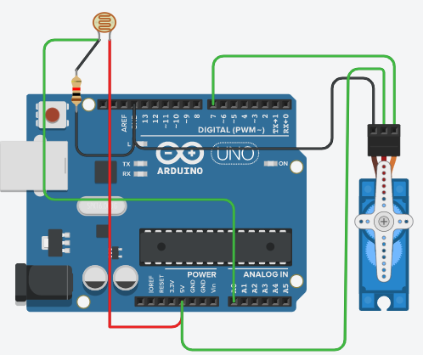

#include <Servo.h>

Servo servo;

int angle = 0;

int senVal=0;

void setup()

{

pinMode(A0, INPUT);

servo.attach(7);

Serial.begin(9600);

}

void loop()

{ senVal=analogRead(A0);

Serial.println(senVal);

if(senVal > 350){

for(angle = 0; angle < 90; angle += 1)

{ servo.write(angle);

}

delay(1000);

}else{

for(angle = 90; angle>=1; angle-=1)

{ angle=0;

servo.write(angle);

} delay(1000); }}

1. What is IR Sensor and Explain its Features?

* Write advantages and disadvantages of IR Sensor

Ans :

An infrared sensor is an electronic device, that emits in order to sense some aspects of the surroundings. An IR sensor can measure the heat of an object as well as detects the motion. }

These types of sensors measures only infrared radiation, rather than emitting it that is called as a passive IR sensor. Usually in the infrared spectrum, all the objects radiate some form of thermal radiations. }

These types of radiations are invisible to our eyes, that can be detected by an infrared sensor. The emitter is simply an IR LED (Light Emitting Diode) and the detector is simply an IR photodiode which is sensitive to IR light of the same wavelength as that emitted by the IR LED. When IR light falls on the photodiode, The resistances and these output voltages, change in proportion to the magnitude of the IR light received.

**IR LED Transmitter**-IR LED emits light, in the range of Infrared frequency. IR light is invisible to us as its wavelength (700nm – 1mm) is much higher than the visible light range. IR LEDs have light emitting angle of approx. 20-60 degree and range of approx. few centimeters to several feet's, it depends upon the type of IR transmitter and the manufacturer. Some transmitters have the range in kilometers. IR LED white or transparent in color, so it can give out amount of maximum light.

**Photodiode Receiver**-Photodiode acts as the IR receiver as its conducts when light falls on it. Photodiode is a semiconductor which has a P-N junction, operated in Reverse Bias, means it start conducting the current in reverse direction when Light falls on it, and the amount of current flow is proportional to the amount of Light. This property makes it useful for IR detection. Photodiode looks like a LED, with a black colour coating on its outer side, Black colour absorbs the highest amount of light.

**Advantages :**

* Their low power requirements make them suitable for most electronic devices such as laptops, telephones, PDAs.
* They are capable of detecting motion in presence/ absence of light almost with same reliability.
* They do not require contact with object to for detection.
* There is no leakage of data due to beam directionality IR radiation.
* They are not affected by corrosion or oxidation.
* They have very strong noise immunity.

**Disadvantages :**

* Required Line of sight.
* Get blocked by common objects.
* Limited range.
* Can be affected by Environmental conditions such as rain, fog, dust, pollution.
* Transmission Data rate is slow

1. Perform an experiment on IR sensor and LED turns on when IR Value goes High and Turn off LED when IR Values goes Low(Write Program code only).

ANS :

int led=7;

int ir=3;

void setup() {

pinMode(led,OUTPUT);

pinMode(ir,INPUT);

Serial.begin(9600);

}

void loop() {

int val=digitalRead(ir);

Serial.println(val);

if(val==1) {

digitalWrite(led,HIGH);

Serial.println(“LED ON”);

} else

{

digitalWrite(led,LOW);

Serial.println(“LED OFF”); } }